**Datatypes**

Data types in C refer to an extensive system used for declaring variables or functions of different types. The type of a variable determines how much space it occupies in storage and how the bit pattern stored is interpreted.

**Integer Types:**

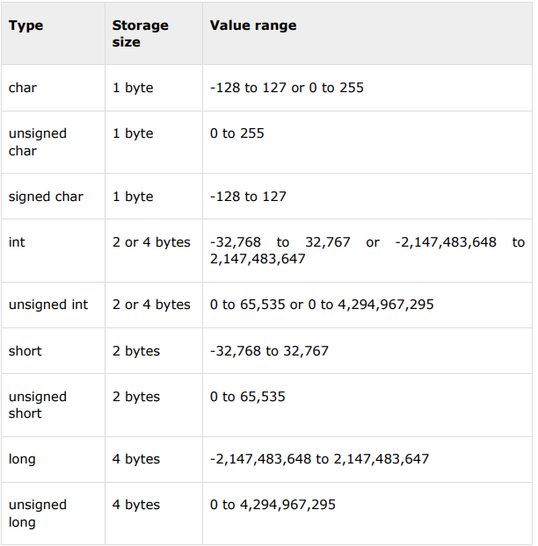

**Floating-Point Types:**

